Practical 2

1) Write a bash script to print from user input.

Code:
echo "Please enter your name!"
read name
echo "Hello! $name"

Output:
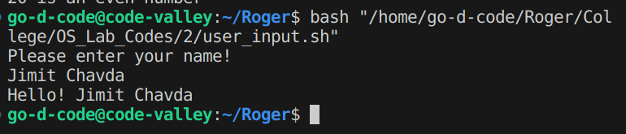

2) Write a bash script to find whether a number is even or odd.

Code;
echo "Enter a number:"
read num
if ((num % 2 == 0)); then
echo "$num is an even number"
else
echo "$num is an odd number"
fi

Output:
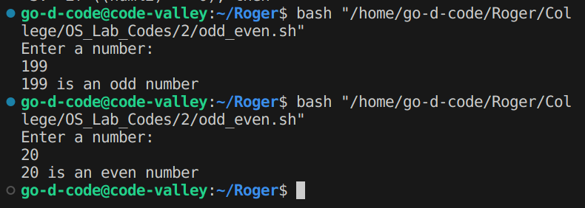

3) Write a bash script to print the table of a given number.

Code:
echo "Enter a number:"
read num
for ((i = 1; i < 11; i++)); do
result=$((num * i))
echo "$num * $i = $result"
done

Output:
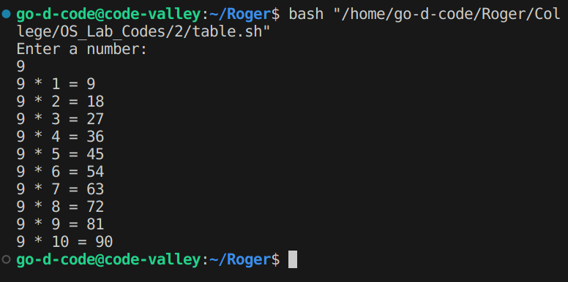

4) Write a bash script to check whether a given no. is prime or not.

Code:
echo "Enter a number:"
read number
i=2

if [ $number -lt 2 ]; then
echo "$number is not a prime number."
exit
fi

while [ $i -lt $number ]; do
if [ $((number % i)) -eq 0 ]; then
echo "$number is not a prime number."
exit
fi
i=$((i + 1))
done
echo "$number is a prime number."

Output:
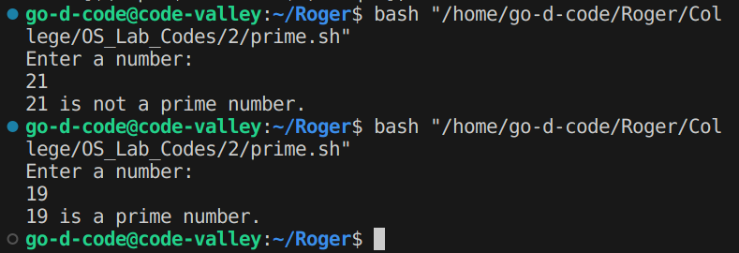

5) Write a bash script to find the simple interest.

Code:
echo "Enter the principle amount:"
read pamount
echo "Enter the interest rate:"
read interest
echo "Enter the number of years:"
read years
net_interest=$((pamount * interest * years / 100))
echo "total return value is $net_interest"

Output:
